Name ______________________________ period____ Date________

Naming Molecular Compounds Worksheet #1
Molecular compounds are made of nonmetals atoms bonded together by sharing electrons. There are NO IONS and NO CHARGE involved in covalent bonding.
When we name any molecular compound, we need to find the name of each element in the compound and to know the prefixes for the total number of atoms of each element in the compound.

1: Name each molecular compound below.

- P₃F₄ e) NO

- BrP₇ f) SiCl₆

- SO₃ g) IF₃

- N₂O₅ h) NCl₃
i) N₂H₄ j) S₂F₁₀
2: Write the formula of each molecular compound.
- Tribromine nonoxide _______________
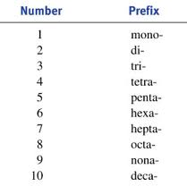
- Nitrogen dioxide__________________
- Sulfur hexafluoride__________________
- Pentoxygen dichloride__________________
- Diboron heptoxide__________________
- Iodine monobromide __________________
- Phosphorous pentachloride __________________
- Iodine heptafluoride__________________
Also:

    - Carbon tetrabromide __________________
    - Diphosphorus trioxide __________________
    - Octanitrogen tetraoxide__________________
    - Phosphorus tribromide__________________
    - Carbon tetraiodide__________________
    - Dinitrogen hexoxide__________________
    - Carbon monoxide__________________

